Scan in Travel
Software Requirement Specification

By
Yirui Wang 542115509
Ruijuan Liu 542115508

Department of Software Engineering
College of Arts, Media and Technology
Chiang Mai University

Project Advisor

Yun Rim Park

Document History
Document Name | Version | Status | Date | Viewable | Editable | Responsible
Documents
Scan in Travel _Software Requirement Specification | Software Requirement Specification_V0.1 | Reviewed |  | Yun Rim Park  Yirui Wang  Ruijuan Liu | Yirui Wang  Ruijuan Liu | Yirui Wang  Ruijuan Liu

Document Approved by

Yun Rim Park

Table of Contents

Chapter One | Introduction........................…….…………………………..…4
1.1 Objective………………......……......…......................……………..4
1.2 Intended Audience and Reading Suggestions......................………..4
1.2.1 Development team..............................………………..….....…4
1.2.2 Customer..............................……...............…………..….....…4
1.3 Project Scope…………….............…...........................……………..5
1.4 Acronyms and Definitions................……...................…….………..6
1.4.1 Acronyms.......................................……………………….....…6
1.4.2 Definitions......................................……………………….....…6

Chapter Two | Overall Description…................….…………………………..8
2.1 Product Perspective……......................…….….......................……..8
2.2 Product Features.......………….....……...……......………...…….…8
2.3 User Classes and Characteristics......……....…......………...……….8
2.4 Operation Environment......……....…......………...…..............…….9
2.5 Design and Implementation Constrains.….......…...…..............……9

Chapter Three | Functional Requirement………..…….…………...……….10
3.1 User Requirement Specification..............................……....…….....10
3.2 User Requirement Specification with the System Requirement Specification.......................……............................................……..11

Chapter Four | Specific Requirement……......................…………..….……15
4.1Use Case Scenarios ……..…..………………...…………….…......15
4.1.1 Use Case Diagram (Entire System)…......………………….…15
4.1.2 Use Case Diagram (Translation System)........…..………….....16
4.1.3 Use Case Diagram (Map System)…....….………………….....16
4.1.4 Use Case Diagram (Favorite System)…....…...…………….....17

4.2 Use Case Description…….....……………….....………………….18
4.2.1 Feature Name (Translation System).....................………….....18
4.2.1.1 Feature Process Flow..............................................….....18
4.2.1.2 Use Case(s).............................................................….....18

Chapter Five |Reference……….….............….................…………………..26

Chapter One | Introduction

1.1 Objective

The objective of the Software Requirement Specification document is to outline all the requirements for “Scan In Travel” application. Clearly and accurately describes each of the essential requirements(functions, performance and design constraints) of the system and its external interfaces. This document is based on the project proposal and project plan. It also contains a general description of the types of users who will be using or application, how it is going to work, and goals.
This document is intended to be used by the members of the project team and other stakeholders who will participate in the design and implementation phases of the project and verify the correct functionality of the system. And the application will be designed followed this document.

1.2 Intended Audience and Reading Suggestions

This Software Requirement Specification was created for everyone that involved with the “Scan In Travel” application. It will make benefits for people as following:

1.2.1 Development team
·Help every members of development team have a good understanding about the requirement and how it is going to work.
·Reduce the development effort.
·Provide a basis for validation and verification.
·Avoid error in work. Verify and specify all requirements to ensure the same understanding about requirements

1.2.2 Customer
·Help customers to accurately describe what they wish to obtain.
·Establish the basis for agreement between the customers and the development team on that the application is to do.

1.3 Project Scope

“Scan in Travel” is a mobile application which using Android OS. This application can help users solve the language problems during their travel in China. Users can get the meaning of Chinese word(s) by scanning it with the built-in camera of their mobile phone. And users can also get the map and route if the scanned name is the name of a Location in China. What is more, “Scan in Travel” can also help users remember where they have been. Users can record the attractive places into their Favorites.
The main features of “Scan in Travel” will be following:

Translation system
Users can translate Chinese word(s) and Location name(s) into English by scanning them with the built-in camera of their mobile phone. After viewing the English translation of the word(s), users can also select the text-to-speech function to listen to the pronunciation of the Chinese word(s). Moreover, users can edit the Chinese word(s) that are scanned to get new explanation in English.

Favorites system
Users can save Chinese words and their English translation to their own Word book. If users scan a Location name, they can also save the Location with its name, pictures, geometry information (i.e. latitude and longitude), and descriptions into their Favorites. Users can take the picture of the Location and write down their own description for it. Moreover, users can sort and search words in their own Word book and Locations in their Favorites.

Map system
Users can keep their own map of every Location that they saved. The system lets users see every saved Location on a map, and check the details of each Location. Besides, users can scan a Location name and find where it is located on a map. The system will guide users to get to the Location by providing a route on a map.

1.4 Acronyms and Definitions

1.4.1 Acronyms
SRS Software Requirement Specification
URS User Requirement Specification

1.4.2 Definitions
Feature Transformation of input parameters to output parameters based on a specified algorithm. It describes the functionality of a product in the language of the product. Used for requirements analysis, design, coding, testing or maintenance.

User interface User interface (UI) is everything designed into an information device with which a human being may interact including display screen, keyboard, mouse, light pen, the appearance of a desktop, illuminated characters, help messages, and how an application program or a Web site invites interaction and responds to it.[1]

UML The Unified Modeling Language (UML) is a general-purpose modeling language in the field of software engineering, which is designed to provide a standard way to visualize the design of a system.[2]

Activity diagram Activity diagrams are graphical representations of workflows of stepwise activities and actions with support for choice, iteration and concurrency. Activity diagrams show the overall flow of control.[3]

Use case A use case is a methodology used in system analysis to identify, clarify, and organize system requirements. The use case is made up of a set of possible sequences of interactions between systems and users in a particular environment and related to a particular goal. It consists of a group of elements (for example, classes and interfaces) that can be used together in a way that will have an effect larger than the sum of the separate elements combined.[4]

Use case diagram A use case diagram at its simplest is a representation of a user's interaction with the system and depicting the specifications of a use case. A use case diagram can portray the different types of users of a system and the various ways that they interact with the system.[5]

Chapter Two | Overall Description

2.1 Product Perspective
“Scan in Travel” is an Android application that uses the built-in camera of a mobile phone to capture the image of a Chinese word, converts that image into text, and translates it into English. Tourists can understand the meaning of the word in text and listen to how it is pronounced in Chinese.
“Scan in Travel” can also use the build-in camera to capture the image of a Location name, and provide the map of the place to help users get to the Location.
In addition, “Scan in Travel” application provides a function to help tourists remember where they have been. Tourists can save the Locations with pictures, descriptions and geometry information (i.e. latitude and longitude) in their Favorites list. It can help tourists record their trip and help them easily return to those Locations.

2.2 Product Features
According to the architecture of our project and the time schedule of senior project, we separated the whole implementation period to four progress and three main features. The description is shown below:
Progress Ⅰ:
Feature #1 Translation system
Progress Ⅱ:
Feature #2 Map system
Feature #3 Favorites system(Part 1: URS-09 ~ URS-15)
Progress Ⅲ:
Feature #3 Favorites system(Part 2: URS-16 ~ URS-22)

2.3 User Classes and Characteristics
The intended users for this application are the tourists who want to travel in China. Foreign tourists might face the language barriers or other problems while traveling in China. They have to have basic English skill to use “Scan In travel” application.

2.4 Operation Environment
• Laptops
-- ASUS K43E
Processor: Intel(R) Core(TM) i5-2410M CPU @ 2.30GHz
Memory: 6.00 GB
Graphics: Intel(R) HD Graphics 3000
Operating System: Window 7 Home Basic

-- Dell Inspiron M4010
Processor: AMD Athlon(tm) ⅡP360 Dual-Core Processor @ 2.30 GHz
Memory: 6.00 GB
Graphics: ATI Mobility Radeon HD 5430
Operating System: Windows 7 Ultimate

• Internet
• Mobile phone: Android Operating System
-- Samsung GT-I9100G
CPU: ARMv7 Processor rev 3 (v7I) Dual-core @ 1.2 GHz
Memory: 1.97 GB
Operating System: Android OS version 4.0.4

2.5 Design and Implementation Constrains
• Developers have to consider about density, size, feature, and hardware from different mobile devices.
• Overload data might effect to the application because mobile device has slow CPUs and limited memory.

Chapter Three | Functional Requirement

3.1 User Requirement Specification
Feature #1 Translation system
URS-01: Users can scan Chinese words and Location names by using built-in camera.
URS-02: Users can view the explanation (i.e. meaning, pronunciation) of the scanned word(s) in English.
URS-03: Users can select Text-to-Speech to get the Chinese pronunciation of the word.
URS-04: Users can edit the Chinese word(s)(or Location name(s)) that are scanned to get the new explanation in English.

Feature #2 Map system
URS-05: Users can view the Location on the map if the scanned word is the name of a Location.
URS-06: Users can view all Locations from their own Favorites on the map.
URS-07: Users can view the map that shows the route from the current position to a Location stored in Favorites.
URS-08: Users can view the map that shows the route from the current position to the Location whose name is scanned.

Feature #3 Favorites system
URS-09: Users can add the scanned Location with its name, pictures, geometry information (i.e. latitude and longitude), and descriptions into their Favorites.
URS-10: Users can delete a Location from their own Favorites.
URS-11: Users can view the Location information with name, pictures, geometry information (i.e. latitude and longitude), and descriptions in their Favorites.
URS-12: Users can sort the Locations in Favorites by district name.
URS-13: Users can sort the Locations in Favorites by date they are added.
URS-14: Users can search Locations by keyword in their Favorites.
URS-15: Users can select Text-To-Speech to get the pronunciation of the Location name in their Favorites.
URS-16: Users can add the scanned words into their own Word book.
URS-17: Users can delete a word from their own Word book.
URS-18: Users can view the Chinese words and related information in their own Word book.
URS-19: Users can sort the words in their Word book by date when they are added.
URS-20: Users can sort the words in their Word book alphabetically.
URS-21: Users can search Chinese words in the Word book by their meaning in English.
URS-22: Users can select Text-To-Speech to get the pronunciation of a Chinese word in their Word book.

3.2 User Requirement Specification with the System Requirement Specification

URS-01: Users can scan Chinese words and Location names by using built-in camera.

SRS-01: System shall invoke the built-in camera of users’ mobile phones.

SRS-02: System shall provide user interface for users to scan Chinese words (or Location names) by using built-in camera.

SRS-03: System shall provide user interface for users to inform that system can recognize simplified Chinese now.

SRS-04: System shall provide instructions for users to tell them how to scan Chinese words.

SRS-05: System shall capture the image of the scanned Chinese words (or Location names).

SRS-06: System shall recognize the Chinese words（or Location names) and convert the image into searchable text of the scanned Chinese words (or Location names).

SRS-07: System shall provide the service for users to change the horizontal size of scanning frame.
SRS-08: System shall provide the user interface to display the error message. “Could not initialize camera. Please try restarting device.”

URS-02: Users can view the explanation (i.e. meaning, pronunciation) of the scanned word in English.

SRS-09: System shall provide a control(e.g. button) for users to choose to get the explanation of the scanned word.

SRS-10: System shall receive the request from users to get the explanation of the scanned word.

SRS-11: System shall send the text of the scanned Chinese word (or Location name) to Microsoft Translator API.

SRS-12: System shall receive the explanation (i.e. meaning, pronunciation) of the scanned word in English.

SRS-13: System shall provide the user interface to display the image of scanned word, the text of the Chinese word and the meaning of the scanned word in English.

SRS-14: System shall provide a control(e.g. button) for users to choose to return the user interface which users can scan the Chinese words.

SRS-15: System shall receive the request from users to return to the user interface which users can scan the Chinese words.

SRS-16: System shall return to the user interface which users can scan the Chinese words and the scanning function will be available.

SRS-17: System shall provide the user interface to display the image of scanned word and the text of the Chinese word only.

URS-03: Users can select Text-to-Speech to get the Chinese pronunciation of the word.

SRS-18: System shall provide a control(e.g. Button) on the interface for users to get the proper Chinese pronunciation of the word.

SRS-11: System shall send the text of the scanned Chinese word (or Location name) to Microsoft Translator API.

SRS-19: System shall receive the pronunciation of the scanned word in Chinese from Microsoft Translator API.

SRS-20: System shall pronounce the word to users in Chinese.

URS-04: Users can edit the Chinese word(s)(or Location name(s)) that are scanned to get the new explanation in English.

SRS-21: System shall provide a control(e.g. Button) on the interface for users to select to edit the text of the scanned Chinese word(s)(or Location name(s)).

SRS-22: System shall provide the user interface for users to edit the text of scanned Chinese word(s)(or Location name(s)).

SRS-23: System shall provide a control(e.g. Button) on the interface for users to indicate that editing is completed.

SRS-10: System shall receive the request from users to get the explanation of the scanned word.

SRS-11: System shall send the text of the scanned Chinese word (or Location name) to Microsoft Translator API.

SRS-12: System shall receive the explanation (i.e. meaning, pronunciation) of the scanned word in English from Microsoft Translator API.

SRS-13: System shall provide the user interface to display the image of scanned word, the text of the Chinese word and the meaning of the scanned word in English.

SRS-14: System shall provide a control(e.g. button) for users to choose to return the user interface which users can scan the Chinese words.

SRS-24: System shall provide the user interface to display the image of scanned word only.

SRS-17: System shall provide the user interface to display the image of scanned word and the text of the edited Chinese word only.

Chapter Four | Specific Requirement

4.1 Use Case Scenarios
4.1.1 Use Case Diagram (Entire System)
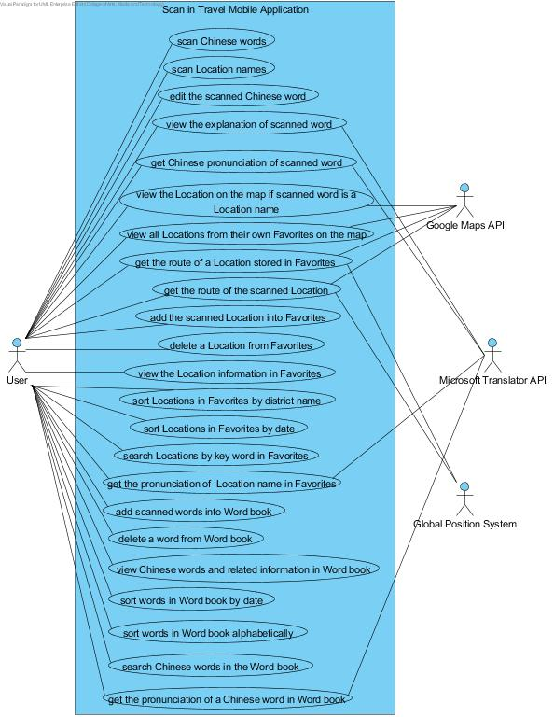
Figure 1: Use Case Diagram of “Scan In Travel” application
4.1.2 Use Case Diagram (Translation System)

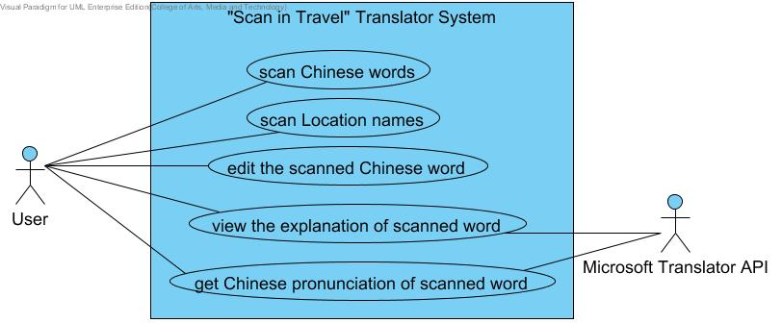
Figure 2: Use Case Diagram of “Scan In Travel” Translator System

4.1.3 Use Case Diagram (Map System)

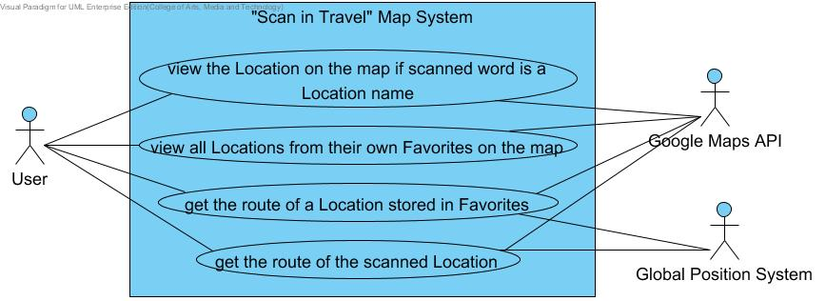

Figure 3: Use Case Diagram of “Scan In Travel” Map System

4.1.4 Use Case Diagram (Favorite System)

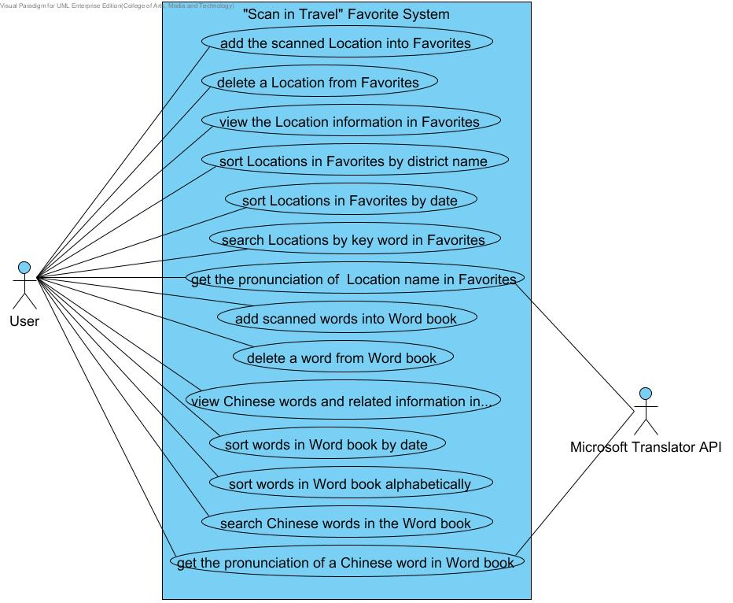
Figure 4: Use Case Diagram of “Scan In Travel” Favorite System

4.2 Use Case Description

4.2.1 Feature Name
Translation system

4.2.1.1 Feature Process Flow
Users can translate Chinese words and Location names into English by scanning them with the built-in camera of their mobile phone. After viewing the English translation of a word, users can also select the text-to-speech function to listen to the pronunciation of the Chinese word. Moreover, users can edit the Chinese word(s) that are scanned to get new explanation in English.

4.2.1.2 Use Case(s)

Use Case ID: | UC-01
Use Case Name: | Scan Chinese words and Location names
Created By: | Ruijuan Liu  Yirui Wang | Last Updated By: | Ruijuan Liu  Yirui Wang
Date Created: |  | Last Revision Date:
Actors: | Users
Description: | Users can scan Chinese word(s) and Location name(s) by using built-in camera.
Trigger: | Users choose to scan Chinese word(s) or Location name(s) in China.
Preconditions: | Users start the ‘Scan in Travel’ application.
Post-conditions: | System shall get the searchable text of the scanned Chinese word(s) (or Location name(s)).
Normal Flow: | 1. Users choose to scan Chinese words or Location names in China.  2. System shall invoke the built-in camera of users’ mobile phones.  3. System shall provide user interface for users to scan Chinese words (or Location names) by using built-in camera.  4. System shall provide user interface for users to inform that system can recognize simplified Chinese now.  5. System shall provide instructions for users to tell them how to scan Chinese words.  6. Users use the built-in camera of their mobile phone to scan the image of a Chinese words (or Location names).  7. System shall capture the image of the scanned Chinese words (or Location names).  8. System shall recognize the Chinese words（or Location names) and convert the image into searchable text of the scanned Chinese words (or Location names).  9. Users view the Chinese text of the scanned Chinese words(or Location names) that they would like to be translated.
Alternative Flows: | In the step 9 of the Normal Flow, if the Chinese text of scanned words are not the one that users want.  - System shall provide the service for users to change the horizontal size of scanning frame.  - Users change the horizontal size of scanning frame to get the accurate recognized Chinese text.  - Use case resumes on the Step 6 of Normal Flow.
Exceptions: | In the step 3 of the Normal Flow, if the system cannot recognize the built-in camera of users’ mobile phone.  1. System shall provide the user interface to display the error message. “Could not initialize camera. Please try restarting device.”  2. Use case resumes on step 2 of the Normal Flow.  In step 6 of Normal Flow, if users do not let the built-in camera aim at the Chinese word (or Location name).  1. System shall not get anything about the searchable text of the scanned image.  2. Use case resumes on step 5 of Normal Flow.
Includes: | N/A
Frequency of Use: | Very Frequently
Special Requirements: | 1. Correctness of the recognition.  2. Speed of the recognition.
Assumptions: | 1. Users understand English.  2. Users know how to scan the words.
Notes and Issues: | 1. What is the maximum length of the scanned words?  2. What is the language that the system can recognize?

Activity Diagram (AD-01):

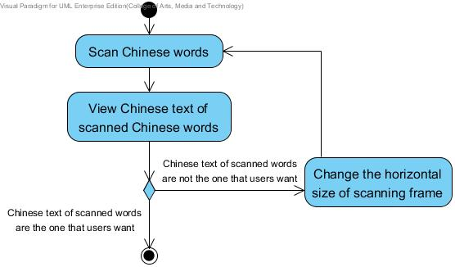
Figure 5: Activity Diagram of “Scan In Travel” UC-01

Use Case ID: | UC-02
Use Case Name: | View the explanation of scanned word
Created By: | Ruijuan Liu  Yirui Wang | Last Updated By: | Ruijuan Liu  Yirui Wang
Date Created: |  | Last Revision Date:
Actors: | Users  Microsoft Translator API
Description: | Users can view the explanation (i.e. meaning, pronunciation) of the scanned word in English.
Trigger: | Users have scanned Chinese word or Location names successfully.
Preconditions: | 1. Users have scanned Chinese word or Location name successfully.  2. System has got the searchable text of scanned Chinese word (or Location name).(UC-01)
Post-conditions: | Users view the explanation (i.e. meaning, pronunciation) of the scanned word in English.
Normal Flow: | 1. Users choose to view the explanation of the scanned word.  2. System shall provide a control(e.g. button) for users to choose to get the explanation of the scanned word.  3. Users choose the “translate” button.  4. System shall receive the request from users to get the explanation of the scanned word.  5. System shall send the text of the scanned Chinese word (or Location name) to Microsoft Translator API.  3. Microsoft Translator API shall translate the text into English.  4. System shall receive the explanation (i.e. meaning, pronunciation) of the scanned word in English from Microsoft Translator API.  5. System shall provide the user interface to display the image of scanned word, the text of the Chinese word and the meaning of the scanned word in English.  6. Users view the meaning of the scanned word in English.
Alternative Flows: | In the step 6 of Normal Flow, if users want to scan Chinese again.  1. System shall provide a control(e.g. button) for users to choose to return the user interface which users can scan the Chinese words.  2. Users choose the “return” button.  3. System shall receive the request from users to return to the user interface which users can scan the Chinese words.  4. System shall return to the user interface which users can scan the Chinese words and the scanning function will be available.  5. Users scan other Chinese word and get their explanations.
Exceptions: | In step 2 of Normal Flow, if no internet access.  - System shall provide the user interface to display the image of scanned word and the text of the Chinese word only.  - Use case ends.  In step 3 of Normal Flow, if the scanned words are not Chinese but some other languages.  - Microsoft Translator API cannot translate the word(s) and return the scanned word(s)(The translation text is same as recognized text).  - Use case resumes on the Step 4 of Normal Flow.
Includes: | UC-01
Frequency of Use: | Frequently
Special Requirements: | Correctness of the translation.
Assumptions: | 1. Users understand English.  2. Users know how to operate smart phones.
Notes and Issues: | What is the language that the system can translate?

Activity Diagram (AD-02):

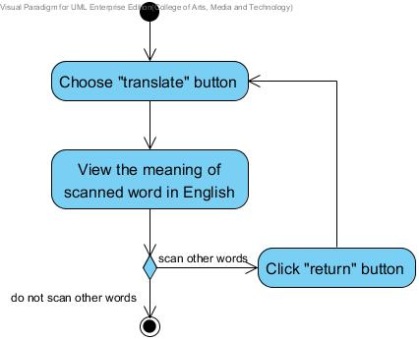

Figure 6: Activity Diagram of “Scan In Travel” UC-02

Use Case ID: | UC-03
Use Case Name: | Get Chinese pronunciation of scanned word
Created By: | Ruijuan Liu  Yirui Wang | Last Updated By: | Ruijuan Liu  Yirui Wang
Date Created: |  | Last Revision Date:
Actors: | Users  Microsoft Translator API
Description: | Users can select Text-to-Speech to get the Chinese pronunciation of the word.
Trigger: | Users choose to get the Chinese pronunciation of scanned word.
Preconditions: | 1. Users have scanned the Chinese word (or Location name) and viewed the explanation of the scanned word successfully. (UC-02)
Post-conditions: | Users get the Chinese pronunciation of the scanned word.
Normal Flow: | 1. System shall provide a control(e.g. Button) on the interface for users to get the proper Chinese pronunciation of the word.  2. Users choose to get the Chinese pronunciation of the scanned word.  3. System shall send the text of the scanned Chinese word (or Location name) to Microsoft Translator API.  4. Microsoft Translator API shall send the pronunciation of the recognized text to system.  5. System shall receive the pronunciation of the scanned word in Chinese from Microsoft Translator API.  6. System shall pronounce the word to users in Chinese.  7. Users get the Chinese pronunciation of scanned word.
Alternative Flows: | N/A
Exceptions: | In step 3 of Normal Flow, if no internet access.  1. System cannot provide the Chinese pronunciation to users.  2. Use case ends.
Includes: | UC-01, UC-02
Frequency of Use: | Very Frequently
Special Requirements: | Correctness of the pronunciation.
Assumptions: | 1. Users understand English.  2. Users know how to operate smart phones.
Notes and Issues: | 1. What language the system can provide the pronunciation?  2. How is the pronunciation of the scanned word?

Activity Diagram:
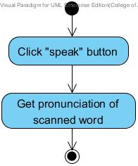

Figure 7: Activity Diagram of “Scan In Travel” UC-03
Use Case ID: | UC-04
Use Case Name: | Edit scanned word
Created By: | Ruijuan Liu  Yirui Wang | Last Updated By: | Ruijuan Liu  Yirui Wang
Date Created: |  | Last Revision Date:
Actors: | Users  Microsoft Translator API
Description: | Users can edit the Chinese word(s)(or Location name(s)) that are scanned to get the new explanation in English.
Trigger: | Users choose to edit the Chinese word(s) of scanned word on display.
Preconditions: | 1. Users have scanned the Chinese word(s)(or Location name(s)) and viewed the explanation of the scanned word successfully.(UC-02)
Post-conditions: | Users get the new explanation of the edited Chinese words.
Normal Flow: | 1. System shall provide a control(e.g. Button) on the interface for users to select to edit the text of the scanned Chinese word(s)(or Location name(s)).  2. Users choose to edit the text of scanned word.  3. System shall provide the user interface for users to edit the text of scanned Chinese word(s)(or Location name(s)).  4. Users edit the scanned Chinese word(s)(or Location name(s)).  5. System shall provide a control(e.g. Button) on the interface for users to indicate that editing is completed.  6. Users choose “Done” button to complete editing and ask to get the new explanation of the edited Chinese word.  7. System shall resume on the UC-02, the step 4 of Normal Flow.  8. Users view the meaning of the edited Chinese word in English.
Alternative Flows: | In step 6 of Normal Flow, if users delete all the words.  1 System shall provide the user interface to display the image of scanned word only.  2. Use case ends.
Exceptions: | In step 6 of Normal Flow, if no internet access.  1. System shall provide the user interface to display the image of scanned word and the text of the edited Chinese word only.  2. Use case ends.  In step 7 of Normal Flow, if no internet access.  1. System cannot provide the explanation to users.  2. Use case ends.
Includes: | UC-01, UC-02
Frequency of Use: | Frequently
Special Requirements: | N/A
Assumptions: | 1. Users understand English.  2. Users know how to operate smart phones.  3. Users know how to edit the word.  4. Users know how to use the keyboard of their phone.
Notes and Issues: | N/A

Activity Diagram:

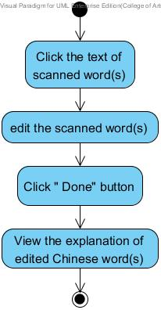
Figure 8: Activity Diagram of “Scan In Travel” UC-04

Chapter Five | Reference

[1] Definition of User Interface
http://searchsoa.techtarget.com/definition/user-interface

[2] Definition of UML
http://en.wikipedia.org/wiki/Unified_Modeling_Language

[3] Definition of Activity Diagram
http://en.wikipedia.org/wiki/Activity_diagram

[4] Definition of Use Case
http://searchsoftwarequality.techtarget.com/definition/use-case

[5] Definition of Use Case Diagram
http://en.wikipedia.org/wiki/Use_Case_Diagram

